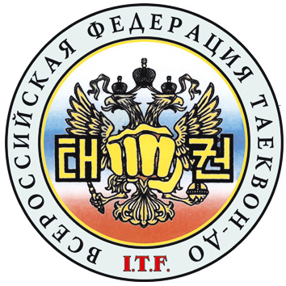 | ОБЩЕРОССИЙСКАЯ ОБЩЕСТВЕННАЯ ОРГАНИЗАЦИЯ  «ВСЕРОССИЙСКАЯ ФЕДЕРАЦИЯ  ТАЕКВОН-ДО И.Т.Ф.»  (495) 995-24-04 , www.tkdrus.ru

International Taekwon-Do Federation
All Russia Taekwon-Do Federation

To: ITF Members
Subject: ITF International Instructor Course
President
Tsilfidis Lazaros
Tel:  007 495 995 24 04
Mab. Tel: 007 926 213 04 34
E-mail: lazos@tkdrus.ru

Official Invitation!
Dear Masters, Instructors and TKD Practioners!
We have the honor to invite you to the IIC to be held in the wonderful region of Tambov
(8 hours from the capital of Russia Moscow).

The IIC will be conducted by the Technical Committee of the ITF masters:
1.Master Hector Marano, 8th Degree, ITF Chairman Technical Committee, Argentina
2.Master Pablo Trajtenberg, 8th Degree< ITF Senior Vice – President, Argentina
3.Master Willem Jacob Bos, 8th Degree, ITF Secretary General, Italy

The course will be held from September 4th, 2009 to September 6th, 2009.
The venue will be Sportshall “Dvorets sporta ANTEI” ul sovetskaya dom 185.

Time schedule will be as follows:
Arrival: Thursday, September 3rd, 2009 at Hotel “Derjavinskaya”, Pashad Lva Tolstogo dom 4
Seminar:

 | 09.00 – 12.00 | 12.00 – 14.00 | 14.00 – 17.00 | 19.00
Friday 04/09/09 | free training | lunch | seminar part I
Saturday 05/09/09 | seminar part II | lunch | seminar part III | Party*
Sunday 06/09/09 | seminar part IV | lunch | seminar part V  and/or grading
Departure: Monday, September 7th, 2009

The ITF International Instructors Course will include the following program and/or qualifications:
1. patterns from Chon-Ji up to Tong-Il
2. step sparring
3. self defence
4. ITF International Instructor Qualification (4th degree and up)
5. grading up to 7th degree (permission from NGB and ITF is needed)
Courses fee, according to the By-Laws, will be as 120,-- € plus 40,-- € inscription fee.
The course fee is waived for VII to IX Degree.
Please note that the complete fees (course-, inscription-, accommodation fee) have to be paid at your arrival in the hotel. We only accept EURO currency!
Special agreement for accommodation fees has been made with:
Hotel “Derjavinskaya”, Pashad Lva Tolstogo dom 4

Room rates: Single bed room 50 €
Double bed room 100 €
Semi lux 130 €
Lux 200 €

In all rates are included breakfast, lunch , dinner.
The Hotel “Derjavinskaya” is located at a 5 Min. By car from the Sportshall “Dvorets sporta ANTEI” ul sovetskaya dom 185.
Baza otdiha “chelnovaya” is located at a 5 Min. By car from the Sportshall “Dvorets sporta ANTEI” ul sovetskaya dom 185

Transfer will be free of charge for all participants and will be paid by the organizers
*Party will be free of charge for all participants and will be paid by the organizers

Send the application form on or before 15 August 2009 .
After the deadline we cannot guarantee for the special price!

Yours in Taekwon-Do

President ITF-Russia The Organizer
Tsilfidis Lazaros

Transfer, by car or by bus, for all participants from no ex-USSR countries from Moscow airports and train stations will be will be free of charge and will be paid by the organizers . If they
If they will confirm their participation until August 15th, 2009 (deadline) and send the exact flight number/train number and time of arrival.
Please note that the time distance by car is 8 hours from Moscow.

